**­­­MIPS Reversi User Manual**

**Locating Files………………………………………………………………………………………………………………………………………2**

Locating Custom MARS Mod……………………………………………………………………………………………………………………2

Locating Game file……………..……………………………………………………………………………………………………………………2

**Running Mars……………………**……………………………………………………………………………………………………………………3

**Running Game……………………………………………………………………………………………………………………….……………4**

Opening the file………………………………………………………………………………………………………………………………….……4

**Playing Music………………………………………………………………………………………………………………………………………6**

Connecting to MARS………………………………………………………………………………………………………………………………..6

Playing music…………………………………………………………………………………………………………………………………………..7

**End……………………………………………………………………………………………………………………………………………………..8**

This game is made with MIPS in the MARS simulator and uses .asm files as code. This game is inspired by the Reversi/Othello game, and runs in the output window of MARS as well as plays music in the background of the game.

To run the program you need a modified version of MARS called KionsMarsMod.jar which will be located in the project folder which can be seen in Figure 1.

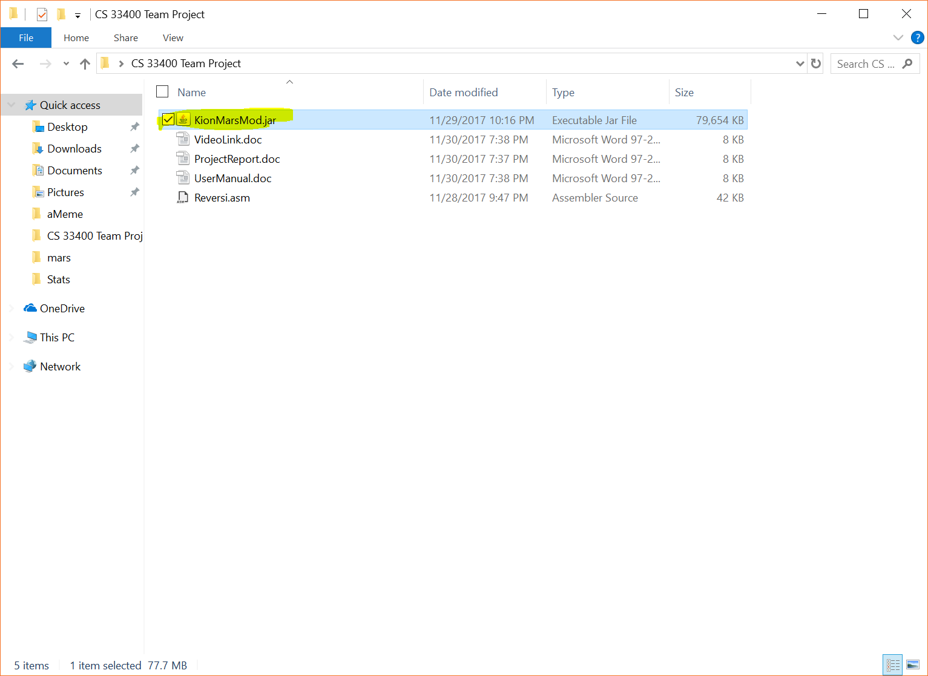

Figure 1 The Jar in the team project folder

The only other item needed to run the game is the Reversi.asm file, which can also be located in the project folder, as seen in Figure 2. You need to load the modified version of MARS, which will look like Figure 3.

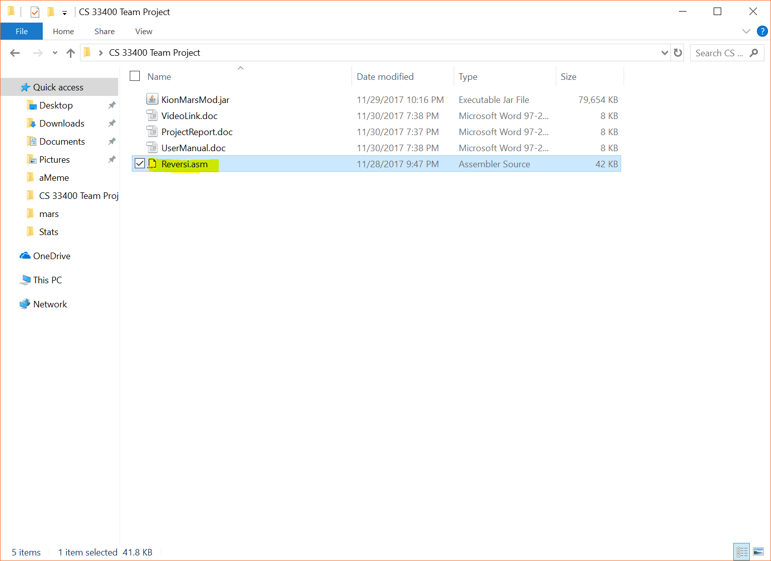

Figure 2 The location of the Reversi.asm file

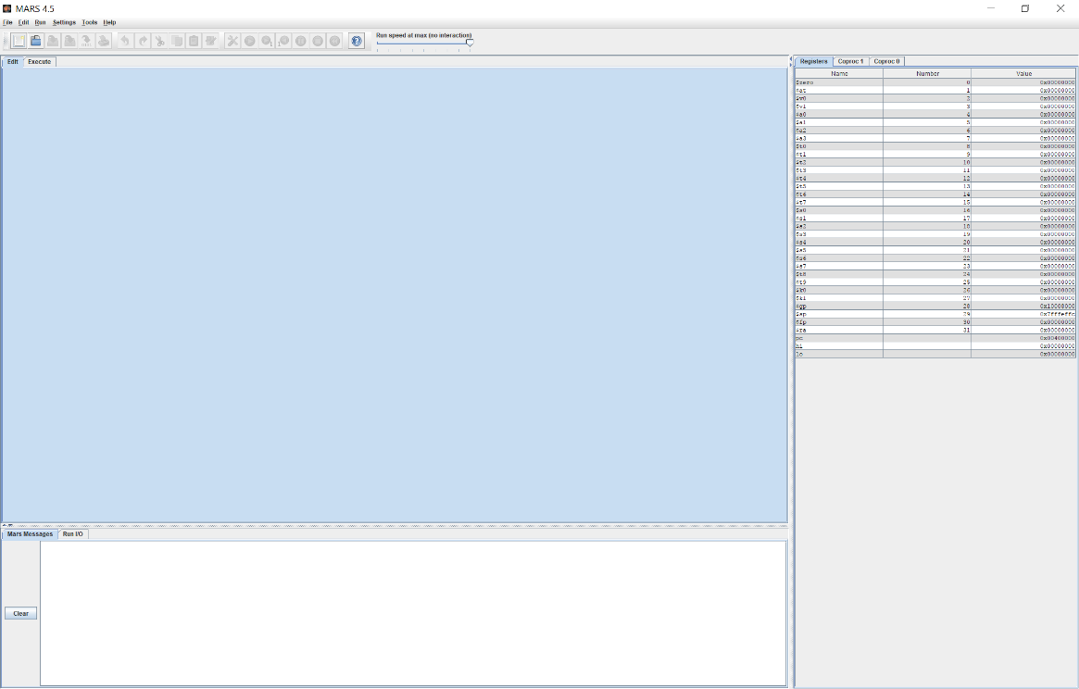

Figure 3 Opening Mars

Next you need to go to File -> Open -> location of Reversi.asm . The steps for this can be seen in figure 4 and 5.

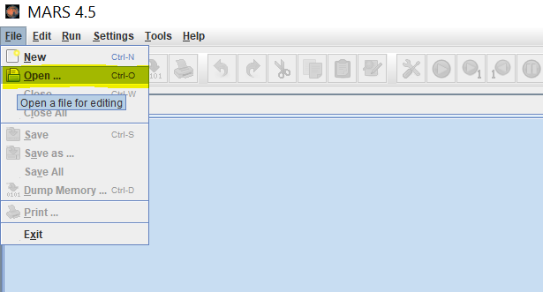

Figure 4 File ->Open



Figure 5 Open the file explorer

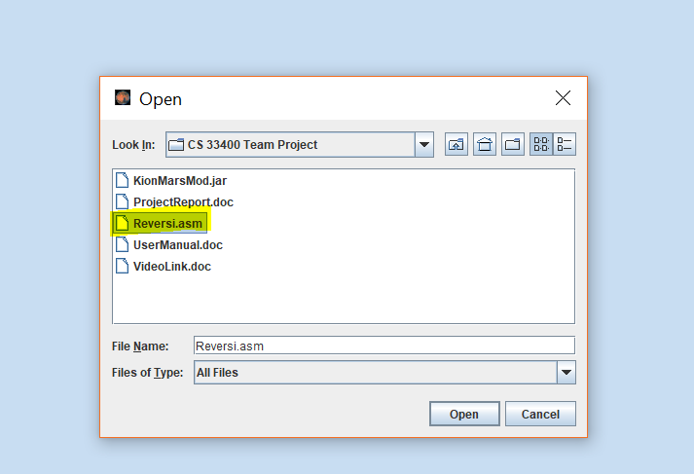

Figure 5 Opening the file

The program should look like Figure 6 when opened.

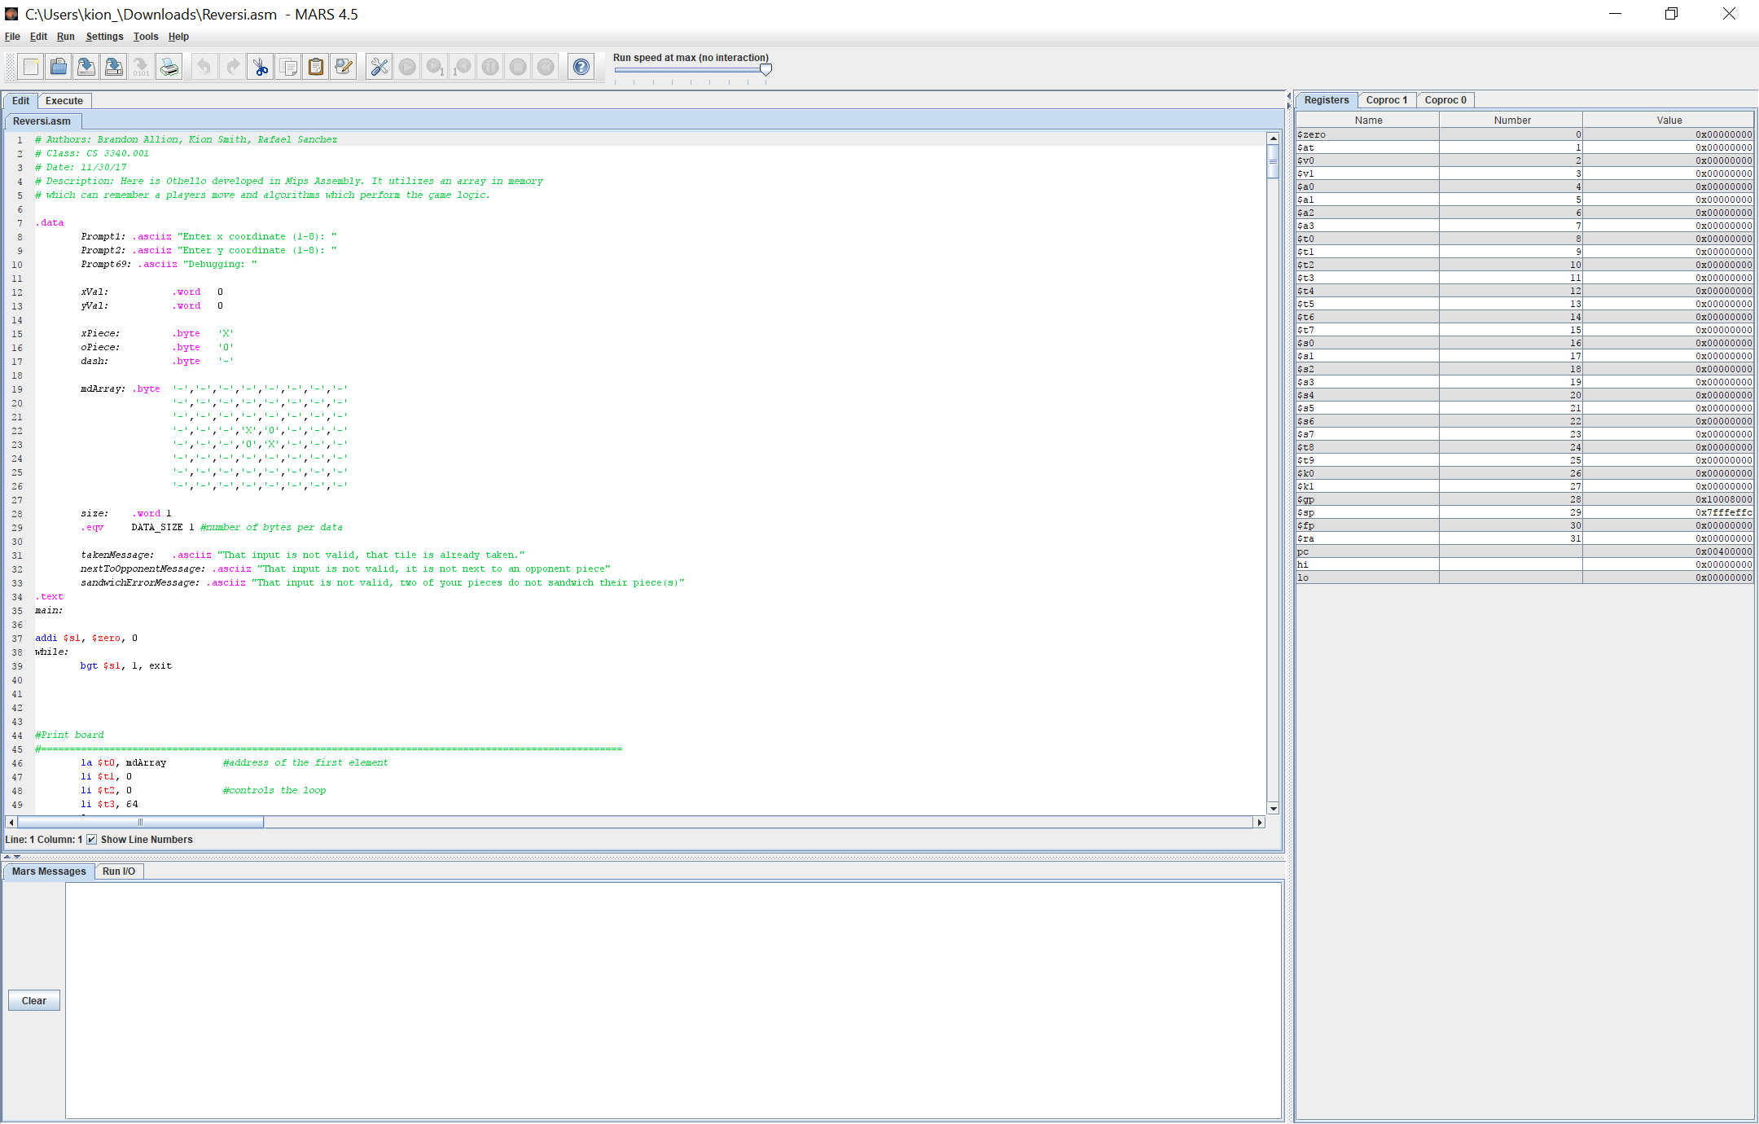

Figure 6 The program

If you want to play the music, you need to go to Tool in the menu bar then select Music Player. See Figure 7.

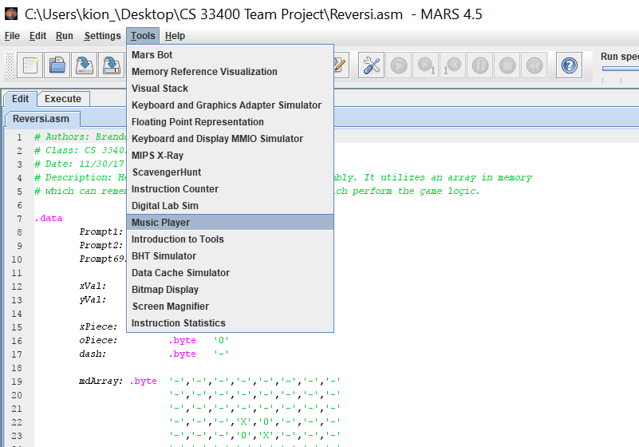

Figure 7 Selecting music player from menu bar item tool

Then you need to connect the music player to Mars, and then press play to start the music, and stop to pause the music. See figure 8

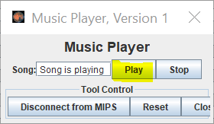

Figure 8 Showing play button for audio player

Then you can compile and run the program and enjoy the music. See figure 9

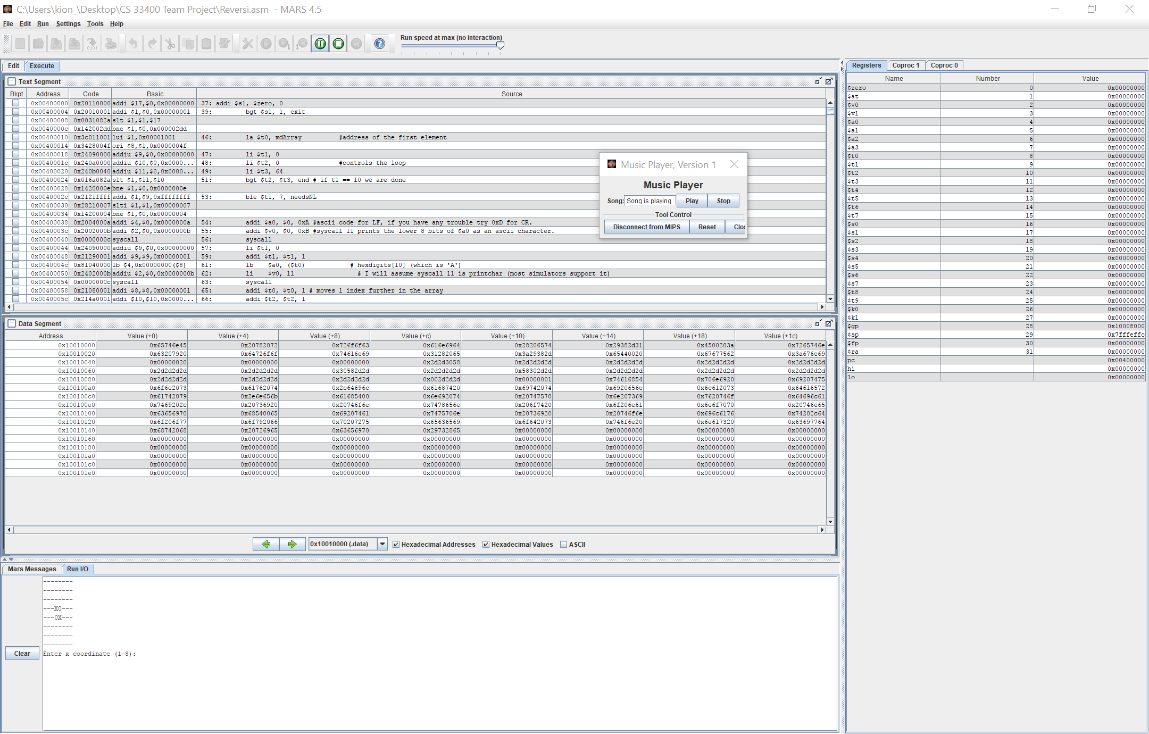

Figure 9 Showing music playing and program running

*NOTE: If you close the program while the music player tool is still connected to MARS, the program will freeze this is the same with all MARS tools.

Playing the game is simple, the command prompts tell you what the range of inputs, and then all you need to do is follow the instructions in the output window and repeat this process until the game end, have fun! See figure 10.

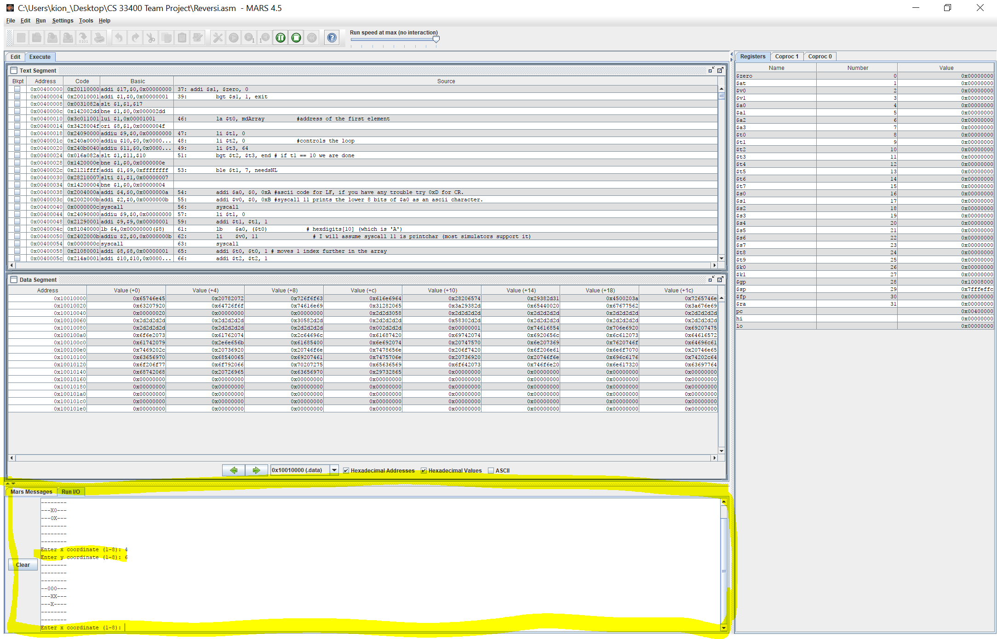

Figure 10 Showing player and computer playing